CPE301 – SPRING 2019

Design Assignment 4B

Student Name: Kyungseo Yun

Student #: 2001091216

Student Email: yunk93@unlv.nevada.edu

Primary Github address: <https://github.com/biscuit0x/submission_yun.git>

Directory: submission_yun/DesignAssignments/DA4B/

Submit the following for all Labs:

1. In the document, for each task submit the modified or included code (only) with highlights and justifications of the modifications. Also, include the comments.
2. Use the previously create a Github repository with a random name (no CPE/301, Lastname, Firstname). Place all labs under the root folder ESD301/DA, sub-folder named LABXX, with one document and one video link file for each lab, place modified asm/c files named as LabXX-TYY.asm/c.
3. If multiple asm/c files or other libraries are used, create a folder LabXX-TYY and place these files inside the folder.
4. The folder should have a) Word document (see template), b) source code file(s) and other include files, c) text file with youtube video links (see template).

1. Components

atmega328p, multi-shield, 22BYJ-48, ULN2003A, jumper cables

2. C code

TASK 1

/*

* Task1.c

* Author : jayne

*/

#define F_CPU 16000000UL

#include <avr/io.h>

#include <avr/interrupt.h>

#include <util/delay.h>

volatile int val = 0; //adc value

void time_i(void) { //CTC mode, prescaler = 8

TCCR1B = (1<<WGM12) | (1<<CS11);

}

void adc_i(void) {

ADCSRA |= (1<<ADEN)| (1<<ADPS2)| (1<<ADPS1)| (1<<ADPS0);//prescale = 128

sei(); //global interrupt

ADMUX |= (1<<REFS0); //reference voltage

PORTC |= (1<<PORTC1); //pull up

DDRC &= (0<<PORTC0); // PC0 as input

}

int main(void)

{

adc_i(); // initialize ADC and timer

PORTB = 0;

DDRB = 15; //PB0-3 as output

time_i();

//loop

while (1)

{

ADCSRA |= (1<<ADSC); //conversion

while((ADCSRA&(1<<ADIF))==0);

ADCSRA |= (1<<ADIF); //reset

val = ADC; // store ADC to val for debugging

OCR1A = 10*val; //95% PWM

PORTB = 9;

while(!(TIFR1 & (1<<OCF1A))); //motor rotation

TIFR1 |= (1 << OCF1A);

PORTB = 3;

while(!(TIFR1 & (1<<OCF1A)));

TIFR1 |= (1 << OCF1A);

PORTB = 6;

while(!(TIFR1 & (1<<OCF1A)));

TIFR1 |= (1 << OCF1A);

PORTB = 12;

while(!(TIFR1 & (1<<OCF1A)));

TIFR1 |= (1 << OCF1A);

}

}

TASK 2

/*

* Task2.c

* Author : jayne

*/

#define F_CPU 16000000UL

#include <avr/io.h>

#include <util/delay.h>

volatile int val = 0; //adc value

void time_i(void) { //timer1 setup

TCCR1A = (1<<COM1A1) | (1<<COM1B1) |(1<<WGM11) ; //fast timer

TCCR1B = (1<<WGM13) |(1<<WGM12) |(1<<CS11) |(1<<CS10); //PWM set up w/ prescale = 64

}

void adc_i(void) {

ADCSRA |= (1<<ADEN)| (1<<ADPS2)| (1<<ADPS1)| (1<<ADPS0);//prescale = 128

ADMUX |= (1<<REFS0); //reference voltage

}

int main(void)

{

adc_i(); // initialize adc and timer

time_i();

while (1) //loop

{

ADCSRA |= (1<<ADSC); //conversion

while((ADCSRA&(1<<ADIF))==0);

ADCSRA |= (1<<ADIF); //reset

ICR1 = 4999; //50Hz

DDRB |= (1<<PB1); //PB1 as output

OCR1A = ADC;

_delay_ms(100);

}

}

3. Schematic

task 1

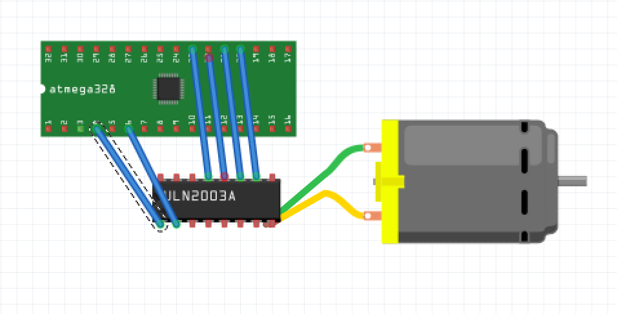

task2

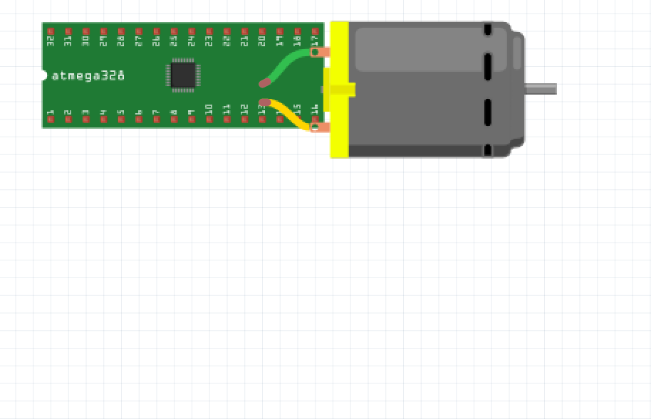

4. screenshot

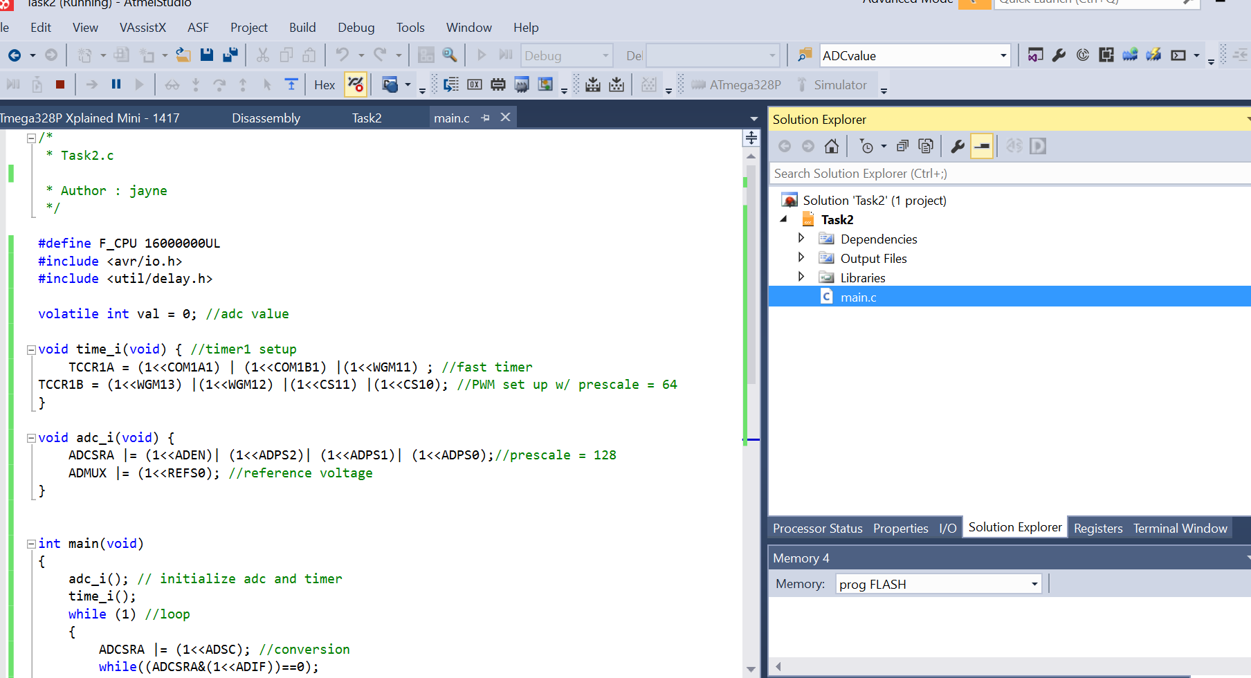

5. Photo / video

Task1

<https://youtu.be/kTStE4A52Ss>

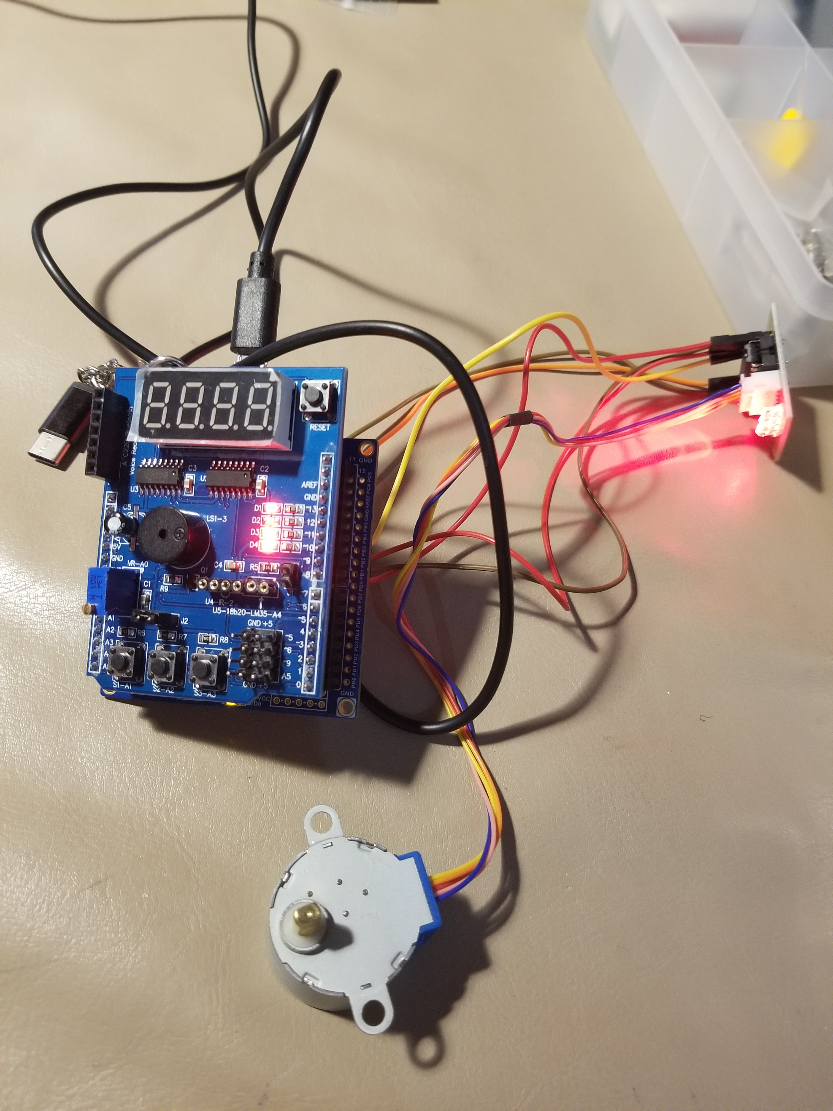

Task2

<https://youtu.be/GVN6_d6tPuI>

